### **CHANGING BACKGROUND FOR SIGN UP PAGE**

### **Aim:**

To create a dynamic and visually engaging sign-up page where the background color smoothly transitions from purple to green, enhancing the user experience and aligning with the app's green theme.

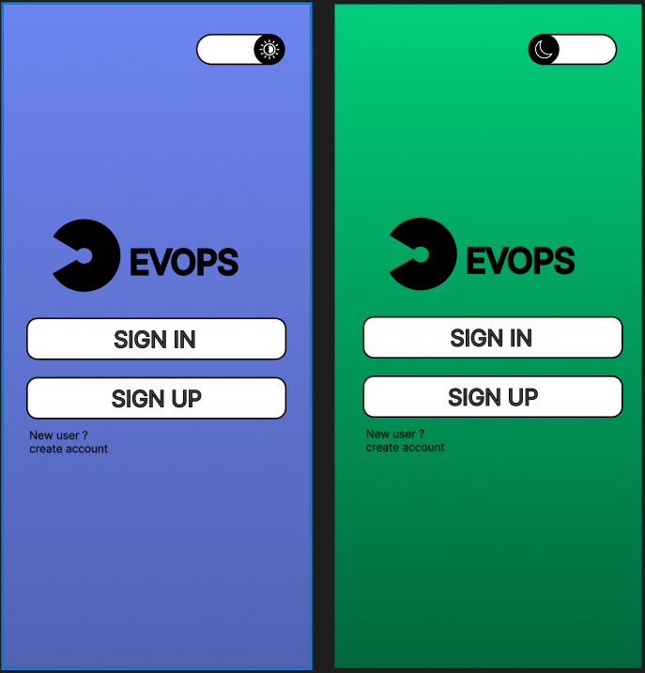

### **Procedure:**

1. **Design the Initial Sign-Up Page:**
   * I started by designing the sign-up page in Figma, setting the background color to **purple** to create a vibrant, welcoming feel.
2. **Implement the Color Transition:**
   * I added an interactive element (e.g., a button or an action) that triggers the color change.
   * Using Figma’s **Prototype** feature, I set up a trigger where the page background transitions from purple to green when the user interacts with the sign-up form (e.g., clicking a "Sign Up" button or completing an input field).
3. **Smooth Animation:**
   * I applied a **smooth transition animation** to the background change to create a seamless visual effect, ensuring that the color shift feels natural and engaging to the user.
4. **Test the Interaction:**
   * I tested the prototype to ensure the background change works smoothly and looks visually appealing, ensuring that the transition doesn’t disrupt the user’s flow.
5. **Refine Based on Feedback:**
   * After testing, I adjusted the timing of the color transition to ensure it wasn't too fast or too slow, ensuring a balanced user experience.

### **Result:**

A dynamic sign-up page with an interactive background that smoothly transitions from purple to green when the user interacts with the form. This change enhances the user experience by visually signaling progression and aligning with the app’s green theme.